24k-0918 DSA LAB-04

Task-01

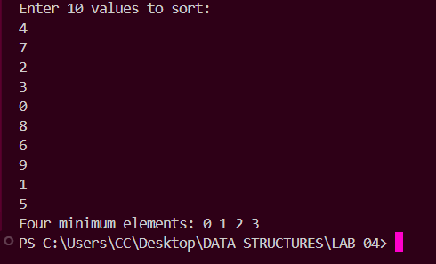

Task-02

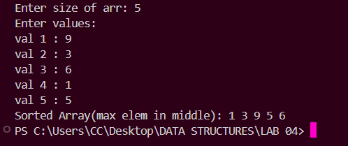

Task-03

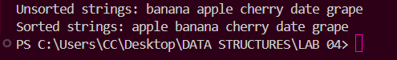

Task-04

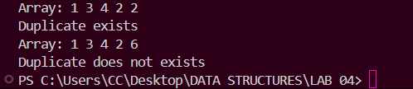

Task-05



Task-06

